

**Custom Encryption and Decryption Software**

**Low-Level Design Version**

**Document Control:**

|  |  |  |  |  |  |  |
| --- | --- | --- | --- | --- | --- | --- |
| **Project Revision History** | | | | | | |
|  |  |  | |  |  |  |
| **Date** | **Version** | **Author** | **Brief Description of Changes** | | | |
|  |  |  |  | | | |
|  |  |  |  | | | |

|  |
| --- |
| **Team Members** |

|  |  |
| --- | --- |
| **Employee ID:** | **Name** |
| 46290121 | Lsv Prasanthi |
| 46290114 | Tamma v k s Prashanhti |
| 46290096 | Kalavathi G |
| 46290095 | A. Lavanya |
| 46290123 | Surya Prabha N |

|  |
| --- |
| **Table of Contents** |

**I) Low-Level Design**

|  |  |
| --- | --- |
| 1. Introduction |  |
| 1.1Purpose | 4 |
| 1.2 Document Conventions | 4 |
| 1.3 Intended Audience and Reading Suggestions | 4 |
| 1.4 References | 4 |
| 1. Detailed system design | 5 |
| 2.1 Design Description | 5 |
| 2.2 Flowchart | 6 |
| 2.3 Story Board | 7 |
| 2.4 Modules |  |

|  |
| --- |
| **Low-Level Design** |

**1.INTRODUCTION**

The aim of this document is to gather, analyze and give an in-depth insight into the complete simulation of different dead lock scenarios and avoiding the dead locks by defining the problem statement in detail. The intended audience includes all stakeholders, Users, and developers. The detailed low-level design of the simulation of different dead lock scenarios and avoiding the dead locks is provided in this document.

### 1.1 Purpose

The purpose of this document is to describe the low-level design flow of the encryption and decryption software.

### 1.2 Document Conventions

TBD (To be continued).

### 1.3 Intended Audience and Reading Suggestions

The document is primarily intended for team members, which consists of trainees under the **Capgemini** Training Program

**1.4 REFRENCES**

The references are:

1. System Requirements Specification Document

[2] System Specification Requirement

## 2. Detailed System Design

**2.1 Design Description**:

The Design description of our project is to save the data files in secured format.

The process of Encryption or Decryption takes place then the Data will be saved in the file and in Decryption process the file will be compared, if the original file matches with the decrypted file, then it will be considered as Decrypted

**2.2 Flowchart**

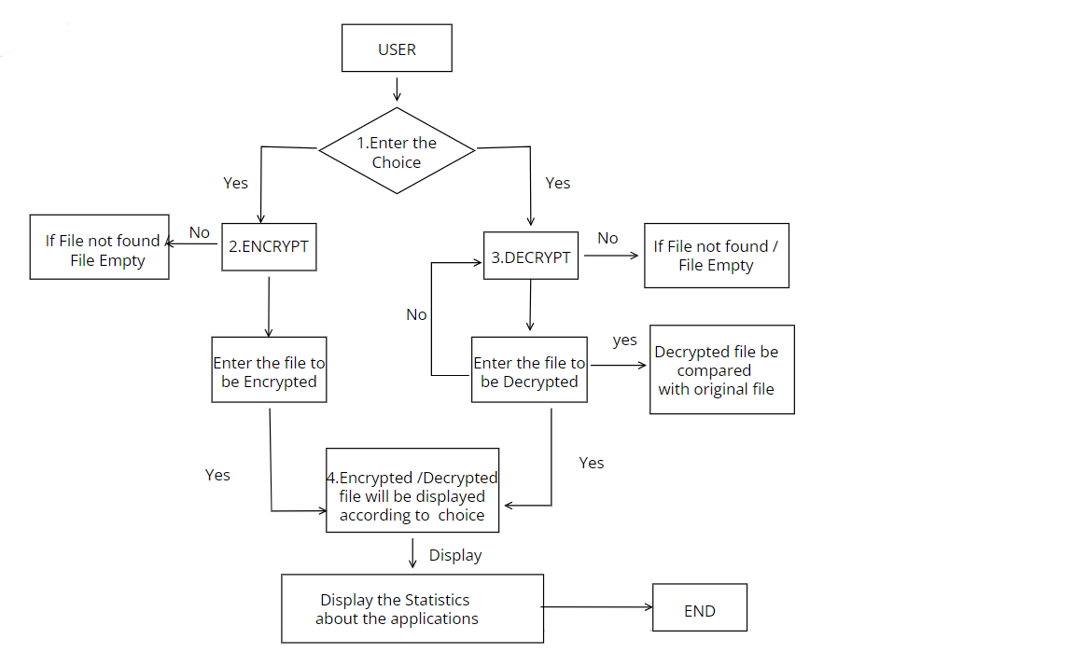

**2.3 Story Board**

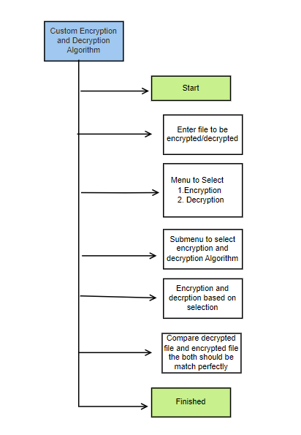

**2.4 Modules:**

### 

**2.4.1 client .c**

**main ():**

|  |  |  |  |  |
| --- | --- | --- | --- | --- |
| **Name** | main | | | |
| **Input** | Parameter Name | NA | Initial value: | NA |
| **Output** | Return value type | int | -  Text Box | - |
| **Description** | The main function will display the user options to the clients. | | | |
| **Pseudo**  **Code** | 1. Display the main menu  2. Wait for user options  3. Based on user input it will move to another | | | |

**2.4.2 main menu ()** :

| **Name** | main menu () | | | |
| --- | --- | --- | --- | --- |
| **Input** | Parameter Name | int | Initial value:NA | - |
| **Output** | Return value type | int |  | - |
| **Description** | This will display the list options in screen | | | |
| **Pseudo**  **Code** | 1. Display the main menu  2. Wait for user options | | | |

**2.4.3 Encryption ():**

| **Name** | main menu () | | | |
| --- | --- | --- | --- | --- |
| **Input** | Parameter Name | int | Initial value:NA | - |
| **Output** | Return value type | int |  | - |
| **Description** | The selected Encryption algorithm should be applied to given file and new encrypted file is stored in different path | | | |
| **Pseudo**  **Code** |  | | | |

**2.4.4 Decryption ()**

|  |  |  |  |  |
| --- | --- | --- | --- | --- |
| **Name** | Display rooms fares () | | | |
| **Input** | Parameter Name | NA | Initial value:NA | - |
| **Output** | Return value  type |  | Text Box | - |
| **Description** | The selected Decryption algorithm should be applied to given file and new decrypted file is stored in different path | | | |
| **Pseudo**  **Code** |  | | | |

**2.4.5 display ()**

|  |  |  |  |  |
| --- | --- | --- | --- | --- |
| **Name** | Display () | | | |
| **Input** | Parameter Name | NA | Initial value:NA | - |
| **Output** | Return value  type |  | Text Box | - |
| **Description** | Display the statics of the file | | | |
| **Pseudo**  **Code** | 1.Take the information from the server  2. Display Encrypted file size as Decrypted file size | | | |